Back

The basics of ConvNets

Quiz, 10 questions

Question 1

1

point

**1. Question 1**

What do you think applying this filter to a grayscale image will do?

⎡⎣⎢⎢01101331−1−3−3−10−1−10⎤⎦⎥⎥

⎣⎢⎢⎡​0110​1331​−1−3−3−1​0−1−10​⎦⎥⎥⎤​



Detect 45 degree edges



Detect image contrast



Detect vertical edges (Correct)



Detect horizontal edges

Question 2

1

point

**2. Question 2**

Suppose your input is a 300 by 300 color (RGB) image, and you are not using a convolutional network. If the first hidden layer has 100 neurons, each one fully connected to the input, how many parameters does this hidden layer have (including the bias parameters)?



9,000,001



9,000,100



27,000,001 (Wrong)



27,000,100 (Correct)

= (300*300*3+1)*100=27,000,100

Question 3

1

point

**3. Question 3**

Suppose your input is a 300 by 300 color (RGB) image, and you use a convolutional layer with 100 filters that are each 5x5. How many parameters does this hidden layer have (including the bias parameters)?



2501



2600 (Wrong)



7500



7600 (Correct)

= 5x5x3x100 + 100 = 7500 + 100 = 7600

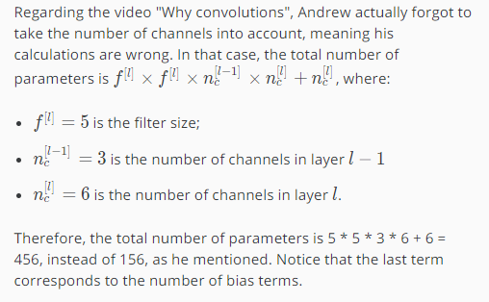

<https://www.coursera.org/learn/convolutional-neural-networks/discussions/weeks/1/threads/ZBXarL8dEeeJcQoBajdpaA>

Question 4

1

point

**4. Question 4**

You have an input volume that is 63x63x16, and convolve it with 32 filters that are each 7x7, using a stride of 2 and no padding. What is the output volume?



16x16x32



29x29x32 (Correct)



16x16x16



29x29x16

= (63+0+7)/2 + 1 = 56/2 + 1 = 28 + 1 = 29

Since there are 32 filters the output volume will be 29x29x32

Question 5

1

point

**5. Question 5**

You have an input volume that is 15x15x8, and pad it using “pad=2.” What is the dimension of the resulting volume (after padding)?



19x19x12



17x17x8



19x19x8 (Correct)



17x17x10

Resulting Volume = (15+4)*(15+4)*(8) = 19x19x8

Question 6

1

point

**6. Question 6**

You have an input volume that is 63x63x16, and convolve it with 32 filters that are each 7x7, and stride of 1. You want to use a “same” convolution. What is the padding?



1



2



3 (Correct)



7

(63+2p-7)/1 + 1 = 63

2p=6

p=3

Question 7

1

point

**7. Question 7**

You have an input volume that is 32x32x16, and apply max pooling with a stride of 2 and a filter size of 2. What is the output volume?



16x16x16 (Correct)



32x32x8



15x15x16 (Wrong)



16x16x8

The formula (n+2p-f)/2 + 1 applies for max pooling as well

(32+0-2)/2 +1= 30/2 + 1= 15 + 1 = 16

The 3rd parameter remains the same, so the output dimension will be 16x16x16

Question 8

1

point

**8. Question 8**

Because pooling layers do not have parameters, they do not affect the backpropagation (derivatives) calculation.



True (Wrong)



False (Correct)

Question 9

1

point

**9. Question 9**

In lecture we talked about “parameter sharing” as a benefit of using convolutional networks. Which of the following statements about parameter sharing in ConvNets are true? (Check all that apply.)



It allows parameters learned for one task to be shared even for a different task (transfer learning).



It allows a feature detector to be used in multiple locations throughout the whole input image/input volume. (Correct)



It allows gradient descent to set many of the parameters to zero, thus making the connections sparse.



It reduces the total number of parameters, thus reducing overfitting. (Correct)

Question 10

1

point

**10. Question 10**

In lecture we talked about “sparsity of connections” as a benefit of using convolutional layers. What does this mean?



Regularization causes gradient descent to set many of the parameters to zero.



Each layer in a convolutional network is connected only to two other layers



Each filter is connected to every channel in the previous layer.



Each activation in the next layer depends on only a small number of activations from the previous layer. (Correct)



I, **MOHAMMAD SHADAN**, understand that submitting work that isn’t my own may result in permanent failure of this course or deactivation of my Coursera account. Learn more about Coursera’s Honor Code